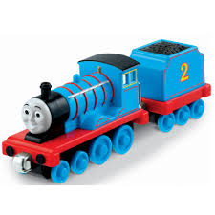

**Thomas the Tank Engine** is a small fictional [steam locomotive](https://en.wikipedia.org/wiki/Steam_locomotive) in [*The Railway Series*](https://en.wikipedia.org/wiki/The_Railway_Series) books by the [Reverend Wilbert Awdry](https://en.wikipedia.org/wiki/Wilbert_Awdry) and his son, Christopher. Kids love to play with train. Gift your kid his favorite train.

Product: Thomas Kid’s Train

Price: 2500 PKR

CONTACT US: Address: Aptech Metro star Gate Karachi

Email: feedback@aptech-education.com.pk